Types of supports
A body kept in a three-dimensional space has six degrees of freedom; translations in three co-ordinate axes and rotations about the three axes.
A body kept on a plane has three degrees of freedom; two translations about x and y axes and rotation about the z axis. If we make a pinned or hinged joint, it prevents the body from moving along the x and y axes but z-rotation is not prevented. |  |  | $$Y_{A}$$  $$X_{A}$$
Hence, a hinged joint can exert reactive forces in two mutually perpendicular directions.
If a support prevents motion in one direction and allows movement in a perpendicular direction, it is called a roller support. There will be only one reaction component for roller support. |  |  |  |  | $$M_{A}$$  $$R_{A}$$  $$X_{A}$$
A fixed support prevents all the degrees of freedom. Hence, the support will have two reactive forces and one reactive moment. |  |  |  | $$Y_{A}$$
The forces and the system of bodies that we deal with in this subject are represented in one plane. That is, we are dealing with only coplanar system. The force system in which all the forces are meeting at one point is known as concurrent force system. If the forces are parallel to each other, it is called a parallel force system. If all types of forces are present, then it is a general case of force system

Freebody diagram
It is a diagram in which a body isolated and free from all its supports and showing all the forces acting on it.
$$W$$
- A ball of weight $W$ resting on a smooth surface. |  | $$R$$
- Three balls of weight W each resting on a trough as shown | $$W$$  $$W$$  $$W$$  $$R_{31}$$  $$R_{1}$$  $$R_{2}$$  $$R_{41}$$ |  | $$W$$  $$W$$  $$W$$  $$R_{3}$$  $$R_{1}$$  $$R_{2}$$  $$R_{41}$$  $$R'$$  $$R'$$  $$R$$  $$R$$
- Three balls of weight W each resting on a surface as shown with a string which keeps the ball from moving. | $$W$$  $$W$$  $$W$$  $$R_{2}$$  $$R_{3}$$ |  | $$W$$  $$W$$  $$W$$  $$T$$  $$R_{1}$$  $$R_{2}$$  $$T$$  $$R$$  $$R'$$  $$R'$$  $$R$$
- A beam AB of weight W hinged at A and supported by a cable at B. | $$A$$  $$B$$ |  | $$B$$  $$Y_{A}$$  $$X_{A}$$  $$W$$  $$T$$  $$A$$
- A beam AB of weight W hinged at A and supported on a roller at B. | $$A$$  $$B$$ |  | $$R_{B}$$  $$B$$  $$Y_{A}$$  $$X_{A}$$  $$W$$

Exercise 1.  Two smooth pipes, each having a mass of 300 kg, are supported by the forked tines of a tractor as shown. Draw the freebody diagram of the two pipes together and then each pipe separately. | 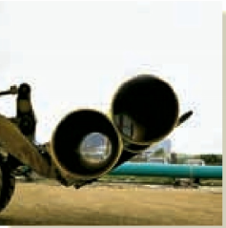 | 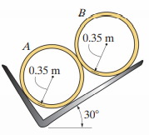
Exercise 2.  Draw the freebody diagram of the beam hinged at both ends A and B. | 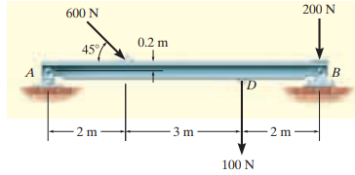

Reference
- Engineering Mechanics: Timoshenko and Young, McGraw Hill
- Mechanics for Engineers: Beer & Johnston, McGraw Hill
- Engineering Mechanics: Merriam & Kraig, Wiley
- Engineering Mechanics: Hibbeler, Pearson

